Hello Webwork Forum!
Hey when you have a moment I was hoping that you could help me solve a presentation issue in the solution of one of my Stat class assignments. The issue is the “e” for a default display of scientific notation. Note that the second to last line below shows the following displays that are confusing to first semester students. | Preferred Integer  display | Default Scientific notation  display
 | -1152  1200 | -1.15 + 03  +1.2 + 03
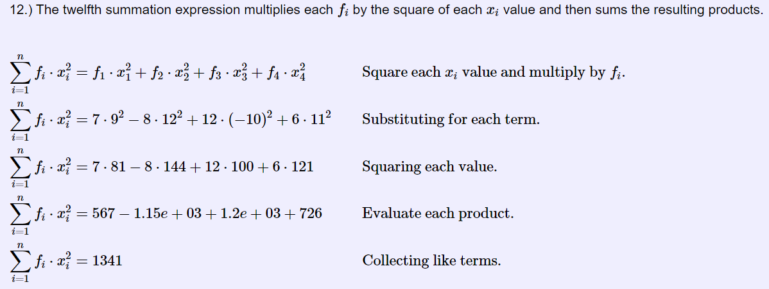

Below is the code block that generates this display:
12.) The twelfth summation expression multiplies each [`f_i`] by the square of each [`x_i`] value and then sums the resulting products.
[``\begin{aligned}&\\
\sum_{i = 1}^{n}f_i \cdot x^2_i &= f_1 \cdot x^2_1 +f_2 \cdot x^2_2 + f_3 \cdot x^2_3 + f_4 \cdot x^2_4 && \text{Square each } x_i \text{ value and multiply by } f_i.\\
\sum_{i = 1}^{n}f_i \cdot x^2_i &= [$f1] \cdot [$x1]^2 ? [$f2] \cdot [$x2]^2+ [$f3] \cdot( [$x3])^2 + [$f4] \cdot[$x4]^2 && \text{Substituting for each term.}\\
\sum_{i = 1}^{n}f_i \cdot x^2_i &= [$f1] \cdot [$x12] ? [$f2] \cdot [$x22] +[$f3] \cdot [$x32] + [$f4] \cdot [$x42] && \text{Squaring each value.}\\
\sum_{i = 1}^{n}f_i \cdot x^2_i &= [$fx12] ? [$fx22] ? [$fx32] +[$fx42] && \text{Evaluate each product.}\\
\sum_{i = 1}^{n}f_i \cdot x^2_i &= [$ans12] && \text{Collecting like terms.}
\end{aligned}``]

If I try to bypass the default scientific notation display by assigning sprintf designations for the variables like shown at the right. This solves the default scientific notation display. However the question marks then come forward which is even more confusing to the student reading the display. The question marks I am pretty sure permit a placement of a “+” or a “-“ based on the sign of the resulting value. But the sprint command interferes with this. | $efx12 =sprintf("%d",$fx12);  $efx22 =sprintf("%d",$fx22);  $efx32 =sprintf("%d",$fx32);  $efx42 =sprintf("%d",$fx42);

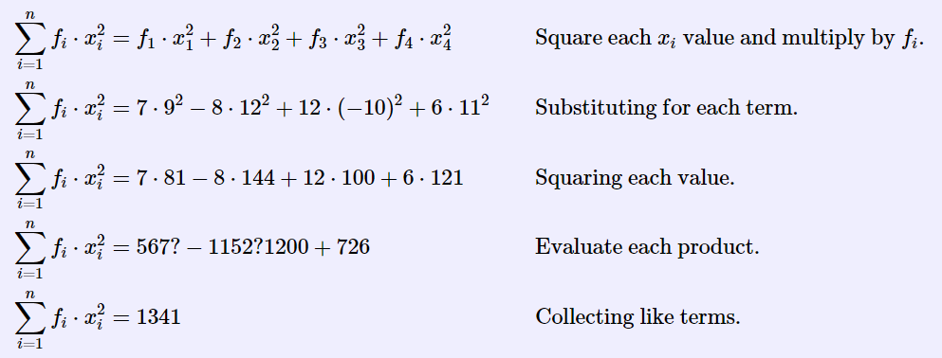

The original variables are Math objects as they were created with Compute(“”) commands. But If I substitute sprintf commands to bypass the default display of scientific notation, then the question marks lose their ability to display and +/- signs and are displayed as questions marks instead.
Is there a way to display integers and still permit the question marks to work in assigning the correct signs to these values in the solution display?

The relevant code lines are 82-97 and 165-171
Any suggestions are truly appreciated.

Best, tim

