Working Group on
Research on Using Technology as a Research and Formative Assessment Tool in the Calculus Classroom

Organizers:
Nicole Engelke, California State University, Fullerton (nengelke@fullerton.edu);
Gulden Karakok, University of Northern Colorado (gulden.karakok@unco.edu);
Aaron Wangberg, Winona State University (awangberg@winona.edu)

Abstract
This research group brings together researchers interested in using technology to investigate how students develop their understanding of calculus concepts. We will share the possibilities of utilizing the open source online homework system WeBWorK, and discuss developing ideas for improving it as (A) a research tool, (B) an instructional tool, and (C) a formative assessment tool within calculus courses. We are very open to discussions about how this technology may be extended beyond calculus.

The working group is intended for active scholars in undergraduate mathematics education, new researchers who are interested in investigating the teaching and learning of calculus, and expert researchers and practitioners who have been using or are planning to use technologies similar to WeBWorK in their research or courses. We will share how we have been using our enhanced WeBWorK system as a research tool and discuss future developments intended to facilitate meaningful discussions in classroom instruction.

We ask participants to share their experience teaching with technology and discuss potential research ideas using such systems. We invite anyone wishing to participate in the discussions to attend by completing the following participation survey: http://magpie.physics.winona.edu/limesurvey/index.php?sid=12296

We will orient our working group session around three main questions.
- How do you envision the WeBWorK system as a research tool?
- How can the WeBWorK system be used as an in-class instructional tool to facilitate meaningful discussion around authentic student work?
- What other technologies or online systems have you used or been using for research and/or in class?
Agenda
Session 1:  Thursday, February 23, 8:00-11:30 | Location:  Embassy Suites Hotel  Chief Poker Jim Room
8:00-8:15 Introductions
8:15-8:45 Sharing experiences with WeBWorK or similar technologies
8:45-9:45 How can WeBWorK be used as a formative assessment tool in class?
9:45-10:45 How can WeBWorK be used as a research tool?
10:45-11:30 Initial brainstorming of plans for the working group.
Session 2:  Thursday, February 23, 5:30-6:30 | Location:  Embassy Suite Hotel  (room TBD)
5:30-6:30 Formalizing plans and creation of communication among group members.

Additional Information about the Working Group’s Questions
- How do you envision the WeBWorK system as a research tool?

During the discussion, we will share the ways we have used the enhanced WeBWorK system to collect data on students’ difficulties with function composition through different strands of first semester calculus (see Figure 1 below). The group will be invited to share what modifications they would like to see and use for collecting meaningful data. We envision WeBWorK as a tool that will compliment qualitative research methods. Discussion is needed to determine how best to implement this.

- How can the WeBWorK system be used as an in-class instructional tool to facilitate meaningful discussion around authentic student work?

We are interested in having students work on problems during instruction followed by a facilitated discussion focused around the student-generated solutions.

- What other technologies or online systems have you used or been using for research and/or in class?

We ask the group to share their experiences using technologies in terms of what worked and did not work as instructional and research tools.

Figure 1: 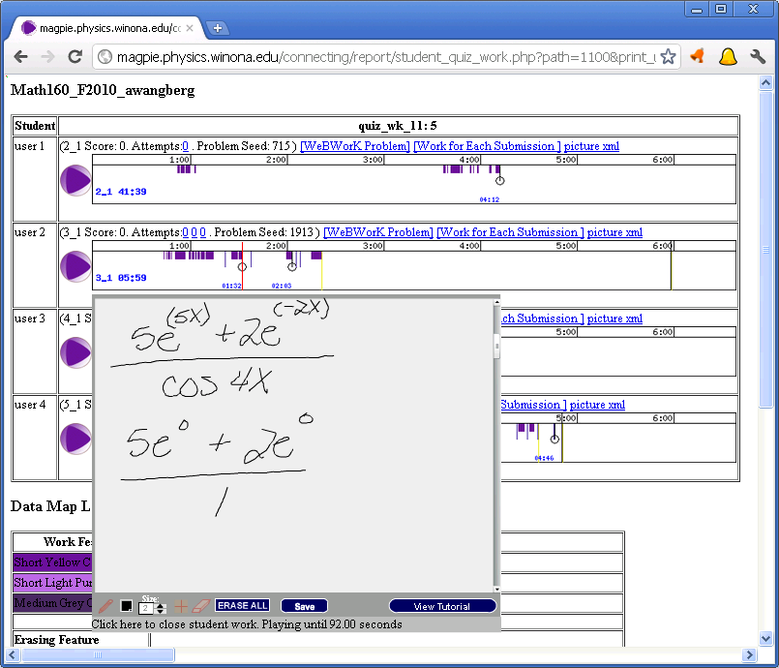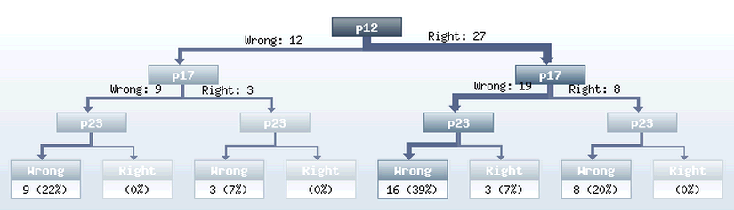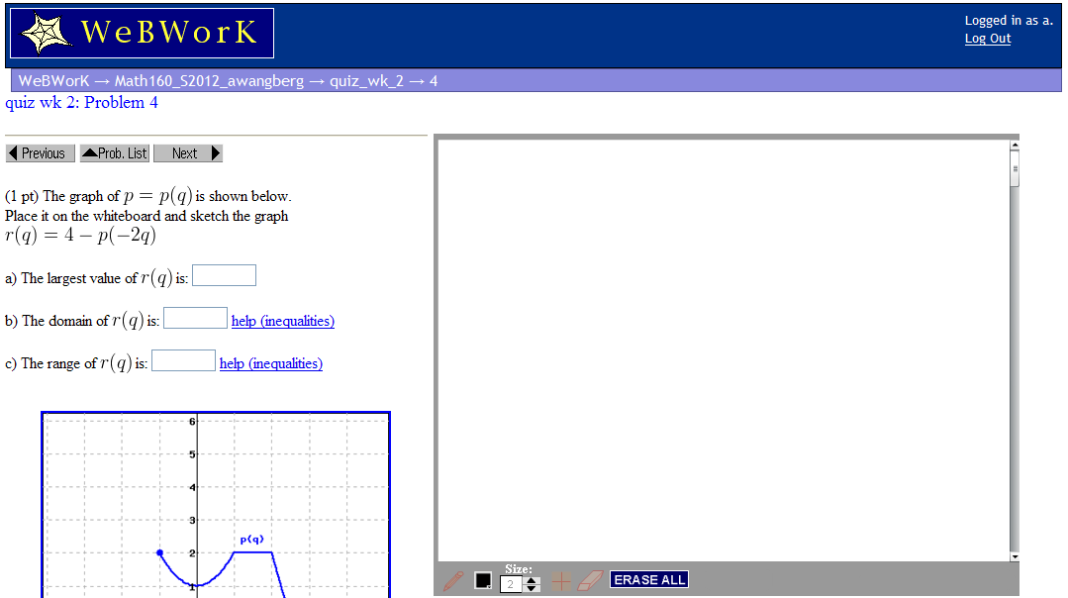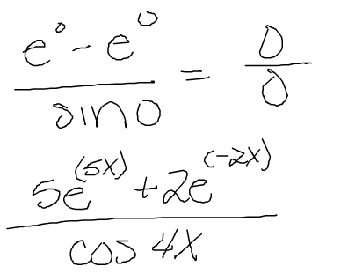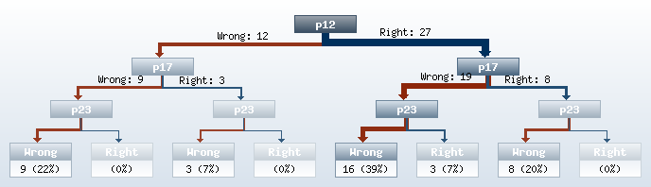

Formative Assessment with Student Abilities categorized on WeBWorK data

