**Attempt to Download a Homework Set for Reuse Elsewhere**

**From the wiki tutorial:**

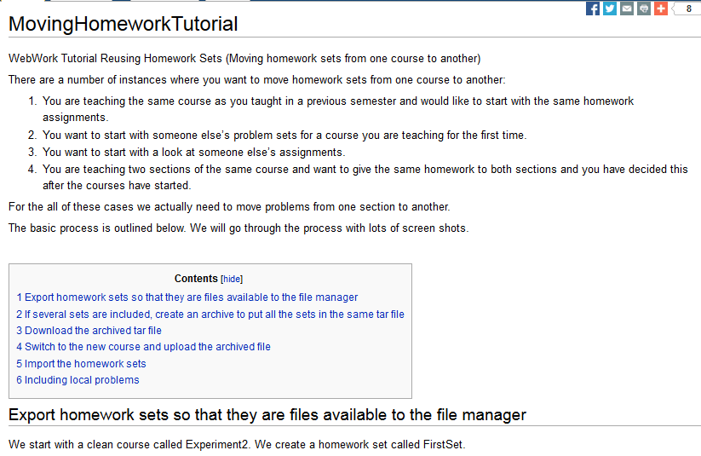

**I am starting with a homework set called RelationsTestSet. I checked this, chose Export, and am about to click on Take Action! This is the screen I obtain.**

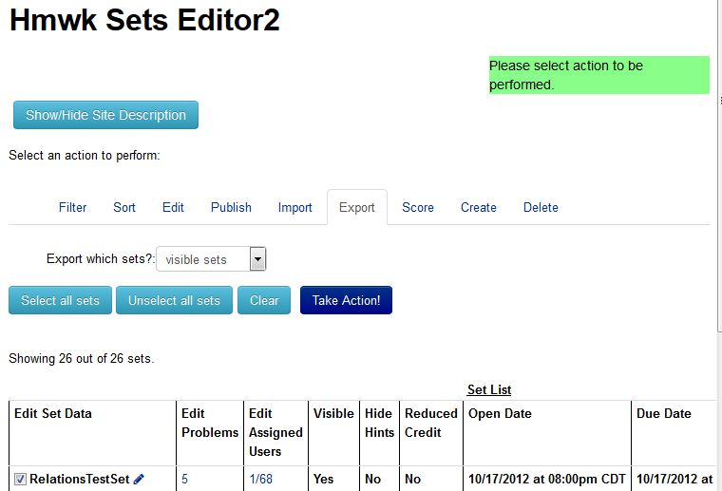

**Now I want to “Save Export”, so on the following screen I will click “Take Action!”. 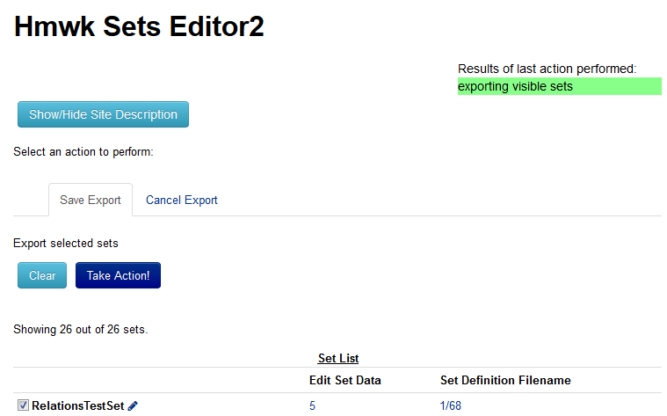This is the screen that next appears:**

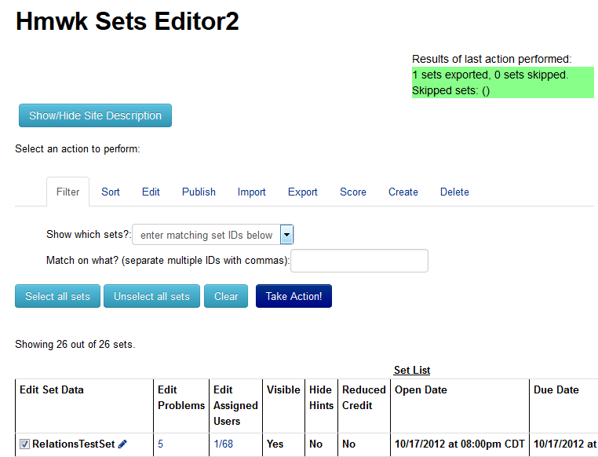

**I now go into File Manager, highlight “setRelationsTestSet.def”, and see the following:** 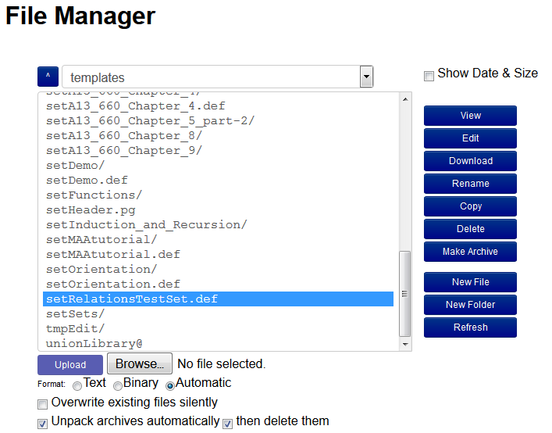

After I click Download, this window pops up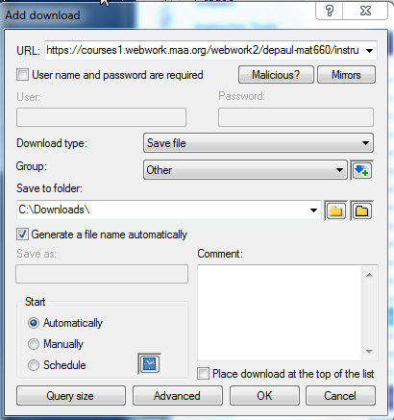:

**I previously created a folder called “Test” under Downloads, so I put this as the file name to be sure to find it, and click OK. Then I get this pop-up (presumably because I’ve tried to download other files from this course):**

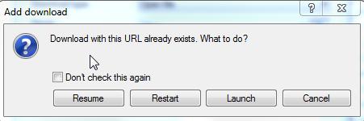

**The only thing that works from this window is “Launch,” so I click it and this is what I get:**

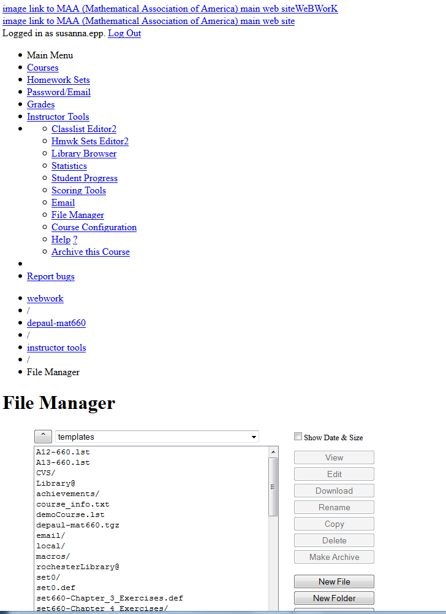

**I must be doing something wrong, but I am mystified. Can you tell me what I need to do to fix this problem?**